**(Practice questions starts from third page)**

**Questions:**

1. Mr. Anil has received Rs. 30,000 as gifts from his relatives during Diwali celebrations. He wanted to save this money in the piggy bank so that he could buy an expensive cricket kit after five years. His father has suggested that he should invest the money in a bank so that the savings could grow. He went through Bank-ka-Bazaar website to find out the options available to him. Calculate the value of the investment after five years under the following options. (Assume annual compounding)

a. SBV is offering FD account at 8% interest p.a.

b. BUB is offering an FD account at 10% interest p.a.

c. HFDC bank is offering FD account at 12% interest p.a.

d. Mr. Aakash, Anil’s father has offered to pay 15% interest p.a.

2. Mr. Binil planned to invest Rs. 60,000 at the end of first year, Rs. 90,000 per year in 2nd and 3rd year-end and Rs. 110,000 in three years thereafter. Calculate the compounded value at the end of year 6 at an interest rate of 10% p.a. (payments are made at the end of the period)

3. Ms. Seema is saving to go to Las Vegas after 10 years. She believes that her plan to go to Las Vegas may cost her 3,000,000. Interest rate is 10%.

1. If She can save 200,000 every year-end for ten years, Is it sufficient to plan a vacation in Vegas? Calculate the short-fall/ surplus.
2. How much does she need to save every year for planning a trip in Las Vegas?
3. if she could save Rs. 175,000 every year, Is it sufficient to plan the trip? If not, calculate the annual short-fall.

4. Your father has promised to give you Rs. 1,000,000 in cash on your 25th birthday. Today is your 15th birthday. How much he should save today in a lump sum so that he could give you Rs. 1 million. You can take the discount rate of 10%. What would be your answer if investment returns are 12% and 15%?

5. Five Installments annuity is Rs. 12,000 beginning at the end of year 10 for 5 years. Calculate present value of annuity at the beginning of year 10 (t=9) and (t=0) (Interest rate=8%).

6. Mr. Manoj is going to receive a pension of Rs. 500 at the end of year 1, Rs. 1000 at the end of year 2 and Rs. 2000 at the end of the years 3 through 5. Calculate the present value if the discount rate is 10%.

--------------

***Extra:***

*7. Mr. Ravi wants to save for the college education of his son, Deepak. Mr. Ravi could save Rs. 40,000 every year-end for five years so that he could pay the fees in lump sum after five years. (College fees is expected to be Rs. 250,000) (discount rate 8%)*

------------

8. Following cash flows are promised by a friend who is working in an investment bank against the investment of Rs. 11,500. There are three plans (A, B, and C). SIB bank is offering an interest rate of 10% on savings deposit. Suggest which plan is better.



9. Calculate the sum of investment after 5 years if (Investments are made today):

a. Rs. 10,000 invested at 20% interest rate compounding annually.

b. Rs. 10,000 invested at 20% interest rate compounding quarterly.

10. Calculate the future value of an investment of Rs. 20,000 offering 10% Interest rate after 20 years. (Investments are made today)

a. If Compounding annually.

b. If compounding semi-annually.

c. If compounding monthly.

11. Calculate the effective interest rate (Annual) under following situation:

a. Stated interest rate 12%, compounding quarterly (4 times a year)

b. Stated interest rate 12%, compounding monthly. (12 times a year)

c. Stated interest rate 12%, compounding daily. (360 days a year)

12. A bank is offering an interest rate of 6% on savings deposit. If the compounding is done on a quarterly basis, what is the effective interest rate (Annual)?

**Practice questions:**

1. Ms. Anu has received Rs. 10,000 from her relatives during the Christmas break. She wanted to save this money so that she could buy some expensive jewelry after ten years. Her brother working in del-lite (accounting firm) suggested investing this money in a bank. Calculate the value of savings under each of these options after ten years if she decides to invest. (Compounding annually)

a. CBIB is offering savings account deposits at 5% interest p.a.

b. BOC is offering saving account deposits at 7% interest p.a.

c. ICC bank is offering savings account deposits at 9% interest p.a.

d. Mr. Prakash, Anu’s father has offered to pay 11% interest p.a.

2. Mr. Binod is planning to save Rs. 10,000 every year for six years, Rs. 20000 per year for 9 years thereafter. Calculate the compounded value at the end of year 15 at an interest rate of 12% p.a. (All savings are made at the end of the period)

3. Mr. Jack Sparrow is saving money to go to an island near the Bermuda triangle after 10 years. He believes that his plan to go to this island for a vacation may cost him Rs. 2,000,000. How much should he save annually (equal amount) to have a sum of Rs. 2 million after 10 years if interest rate is 8%. (Savings are made at the end of the period)

4. Calculate the present value of Rs. 500,000 receivable after 10 years. The discount rate is 5%. What would be your answer if the discount rates are 6% and 8%?

5. Six equated annual Installments of Rs. 50000 beginning at the end of 1st year. Calculate present value of annuity. What would be the value of sum today? (Interest rate = 10%)

6. Discount rate is 10%. Calculate the present value of stream of cash flows given below:

(1) Rs. 1000 at the end of year 1 and 2,

(2) Rs. 2000 at the end of year 3, 4 and 5,

(3) Rs. 5000 at the end of the years 6 through 10.

**------------**

**Extra:**

*7. Ms. Ravina wants to save for the college education of his son, Deepak. Ms. Ravina needs 3,000,000 for one year course (MSc. in Finance) at WOW university in London. How much he should save every year end (equal amount) for five years so that he could pay the fees in lump sum. (discount rate 8%)*

------------

8. Following cash flows are promised by a friend who is working in an investment bank. There are three plans (A, B, and C). SIB bank is offering an interest rate of 10% on savings deposit. Second column shows the deposits made. Calculate the present value and suggest which option is better.

Year 0 1 2 3 4 5

A -20000 2000 4000 6000 8000 10000

B -15000 5000 4000 3000 2000 1000

C -18000 5000 5000 5000 5000 5000

9. Calculate the sum of investment after 10 years if (Investments are made today):

a. Rs. 10,000 invested at 10% interest rate compounding annually.

b. Rs. 10,000 invested at 10% interest rate compounding quarterly.

10. Calculate the future value of an investment of Rs. 20,000 offering 10% Interest rate after 20 years. (Investments are made today)

a. If Compounding annually.

b. If compounding quarterly.

c. If compounding daily.

11. Calculate the effective interest rate (Annual) under following situation:

a. Stated interest rate 20%, compounding quarterly (4 times a year)

b. Stated interest rate 20%, compounding monthly. (12 times a year)

c. Stated interest rate 20%, compounding weekly. (52 times a year)

12. A bank is offering an interest rate of 12% on savings deposits. If the compounding is done on a monthly basis, what is the effective interest rate (Annual)?

**Extra Practice questions:**

**Loan Amortization**

You have borrowed a 3-year loan of Rs. 10,000 at 9% from your employer to buy a motorcycle. If your employer requires 3-equal end-of-the year repayment, then the Installment amount would be?



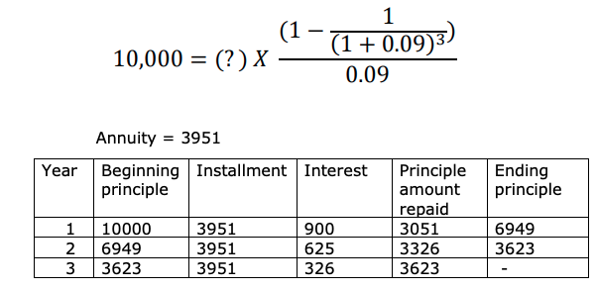

**Mini case**

Suppose you are exactly 30 years old. You believe that you will be able to save certain amount for the next 20 years until you are of age 50. For 10 years following that and till the retirement age of 60, you will have a spike in your expenses and you would not be able to save anything. If you guarantee yourself Rs. 100,000 per year starting from your 61st birthday for next 20 years. – How much should you save every year starting at the end of this year. (assume that your investments are expected to yield 8%).

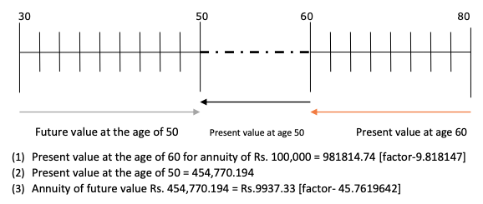

**Question**

Your father has promised to give you Rs. 1,00,000 in cash on your 25th birthday. Today is your 16th birthday. He wants to know the following:

a. If he makes annual payment into the funds, how much each will have to be if funds pay 8%. [8007.69]

b. If he decides to invest a lump sum in the account after 1 year & if it is compounding annually, how much will the lump sum be? [50025]

c. If in (a) the payments are made in the beginning of the year, how much will be the annuity? (Interest rate 8%) [7414.55].

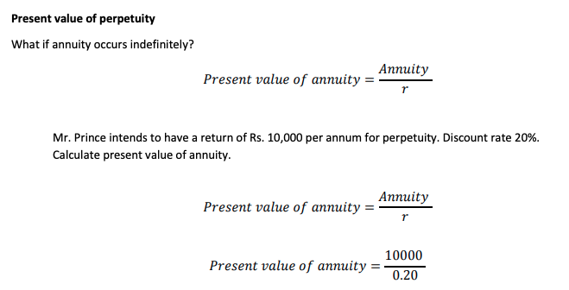

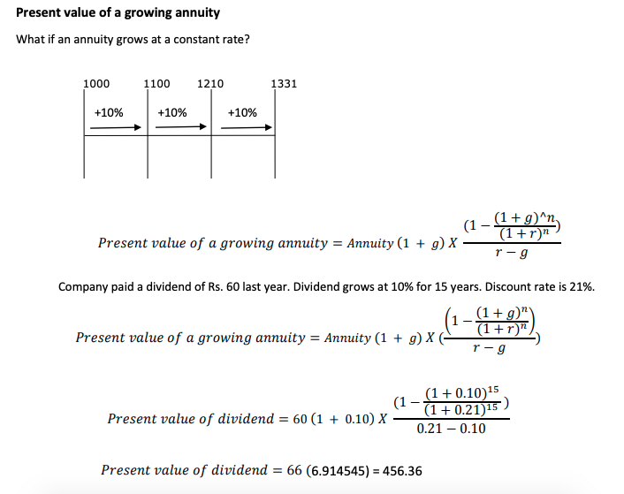

## 

## 

## 

## 

## 

## 

## 

## 

## 

## 

## 

## 

## 

## What Is the Stated Annual Interest Rate?

The stated annual interest rate (SAR) is the return on an investment (ROI) that is expressed as a per-year percentage. It is a simple interest rate calculation that does not account for any compounding that occurs throughout the year.

The effective annual interest rate (EAR), on the other hand, does account for intra-year compounding, which can occur on a daily, monthly or quarterly basis.

